**ML high-level overview:**

**1. Understanding the Problem:**

• Define the problem and business objectives.

• Identify the target variable.

• Understand stakeholders' requirements.

• Example: Predicting customer churn for a telecommunications company.

**2. Data Collection:**

• Gather relevant data that will be used to train and test the machine learning model.

• SQL queries to extract data from databases.

• APIs to fetch data from web services.

• File I/O operations (e.g., pandas.read_csv, pandas.read_excel) for local files.

• Example: Collecting customer demographics, usage patterns, and churn status.

Code:

import pandas as pd

# Load dataset

df = pd.read_csv('customer_data.csv')

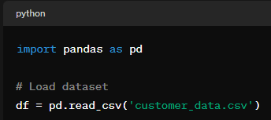

**3. Data Preprocessing:**

• Clean the data by handling missing values, removing duplicates, and dealing with outliers.

• Transform categorical variables into numerical format through encoding techniques like one-hot encoding.

• Scale numerical variables to have similar ranges using techniques like Min-Max scaling or Standard scaling.

• Handle missing data:

• Imputation: Replace missing values with a suitable statistic (mean, median, mode).

• Deletion: Remove rows or columns with missing values.

• Handle outliers:

• Identify outliers using statistical methods (e.g., Z-score, IQR).

• Decide whether to remove, cap, or transform outliers.

• Data normalization and scaling:

• Scale numerical features to a similar range (e.g., Min-Max scaling, Standard scaling).

• Data transformation:

• Encode categorical variables using techniques like one-hot encoding or label encoding.

• Convert date and time variables into appropriate formats.

• Missing data handling: pandas.DataFrame.fillna, scikit-learn.impute.SimpleImputer.

• Outlier detection and treatment: Statistical methods (e.g., Z-score, IQR), scikit-learn.ensemble.IsolationForest.

• Encoding categorical variables: pandas.get_dummies, scikit-learn.preprocessing.OneHotEncoder, scikit-learn.preprocessing.LabelEncoder.

• Scaling and normalization: scikit-learn.preprocessing.MinMaxScaler, scikit-learn.preprocessing.StandardScaler.

• Example: Imputing missing values with mean or median, removing duplicate records, and scaling numerical features.

1. Clean data: Handle missing values, duplicates, outliers.
2. Transform data: Encode categorical variables, scale numerical features.
3. Example: Impute missing values, remove duplicates, scale numerical features.

Code:

from sklearn.preprocessing import StandardScaler

# Handle missing values

df.fillna(df.mean(), inplace=True)

# Scale numerical

features scaler = StandardScaler()

df[['Age', 'Income']] = scaler.fit_transform(df[['Age', 'Income']])

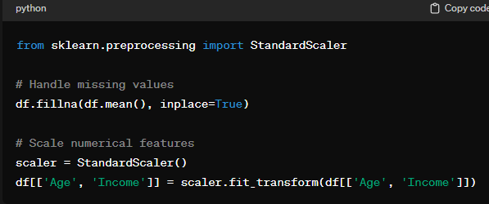

**4. Exploratory Data Analysis (EDA):**

• Explore the data visually and statistically to understand patterns, relationships, and anomalies.

• Use techniques like histograms, scatter plots, correlation analysis, and box plots.

• Summary statistics:

• Calculate descriptive statistics (mean, median, mode, standard deviation, etc.).

• Data visualization:

• Univariate analysis: Histograms, box plots, bar plots.

• Bivariate analysis: Scatter plots, pair plots, correlation matrices.

• Multivariate analysis: Heatmaps, parallel coordinates plots.

• Identify patterns, trends, and relationships in the data.

• Descriptive statistics: pandas.DataFrame.describe.

• Data visualization libraries: matplotlib, seaborn, plotly.

• Correlation analysis: pandas.DataFrame.corr, seaborn.heatmap.

• Example: Visualizing the distribution of customer ages, exploring correlations between features, and identifying outliers.

1. Explore data visually and statistically.
2. Techniques: Descriptive statistics, data visualization, correlation analysis.
3. Example: Visualize customer age distribution, explore feature correlations.

Code:

import seaborn as sns

import matplotlib.pyplot as plt

# Visualize age distribution

sns.histplot(df['Age'])

plt.title('Customer Age Distribution')

plt.show()

# Explore feature correlations

sns.heatmap(df.corr(), annot=True)

plt.title('Correlation Matrix')

plt.show()

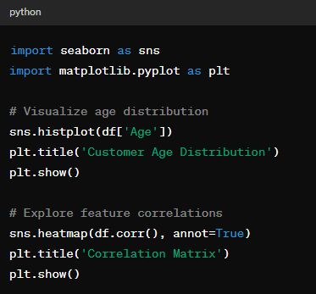

**5. Feature Engineering:**

• Create new features or transform existing ones to improve the model's performance.

• Feature creation:

• Create new features based on domain knowledge or interaction between existing features.

• Feature selection:

• Select relevant features using techniques like correlation analysis, feature importance, or dimensionality reduction.

• Feature transformation:

• Transform features using techniques like polynomial features, log transformation, or scaling.

• Examples include creating interaction terms, binning numerical features, and deriving new features from existing ones.

• Feature creation: pandas.DataFrame.apply, custom functions.

• Feature selection: scikit-learn.feature_selection.SelectKBest, scikit-learn.feature_selection.RFE.

• Feature transformation: scikit-learn.preprocessing.PolynomialFeatures, numpy.log.

• Example: Creating a new feature representing the ratio of total usage to tenure for each customer.

1. Create new features or transform existing ones.
2. Techniques: Feature creation, selection, transformation.
3. Example: Create a feature representing usage-to-tenure ratio.

Code:

df['Usage_to_tenure_ratio'] = df['Usage'] / df['Tenure']

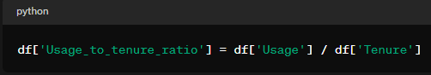

**6. Model Selection:**

• Choose the appropriate machine learning algorithms based on the problem type (e.g., classification, regression) and data characteristics.

• Experiment with different algorithms and evaluate their performance using cross-validation.

• Define evaluation metrics:

• Choose appropriate metrics based on the problem type (classification, regression, clustering).

• Algorithm selection:

• Select candidate algorithms based on the problem requirements, data characteristics, and computational resources.

• Algorithm evaluation:

• Evaluate candidate algorithms using cross-validation and validation set performance.

• Evaluation metrics: scikit-learn.metrics.accuracy_score, scikit-learn.metrics.precision_score, scikit-learn.metrics.recall_score, scikit-learn.metrics.f1_score.

• Cross-validation: scikit-learn.model_selection.cross_val_score, scikit-learn.model_selection.GridSearchCV.

• Example: Trying logistic regression, decision trees, random forests, and gradient boosting for the churn prediction problem.

1. Choose appropriate algorithms.
2. Experiment and evaluate using cross-validation.
3. Example: Try logistic regression, decision trees for churn prediction.

Code:

from sklearn.model_selection import train_test_split

from sklearn.linear_model import LogisticRegression

# Split data into training and testing sets

X_train, X_test, y_train, y_test = train_test_split(df.drop('Churn', axis=1), df['Churn'], test_size=0.2, random_state=42)

# Train logistic regression model

model = LogisticRegression()

model.fit(X_train, y_train)

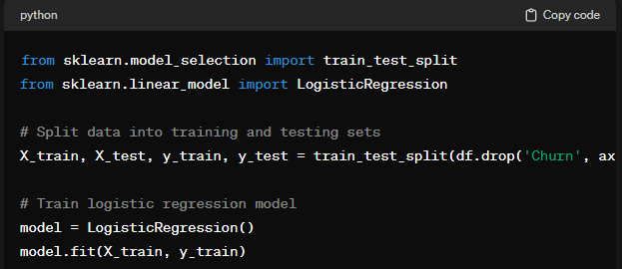

**7. Model Training:**

• Split the data into training and testing sets.

• Train the selected machine learning models on the training data.

• Split data:

• Split the dataset into training, validation, and testing sets.

• Train models:

• Train selected algorithms on the training data.

• Model validation:

• Validate model performance on the validation set to fine-tune hyperparameters.

• Splitting data: scikit-learn.model_selection.train_test_split.

• Training models: scikit-learn.model_selection.fit.

• Example: Training a logistic regression model on 80% of the data.

1. Split the dataset into training and testing sets using train_test_split.
2. Use logistic regression as the chosen algorithm for training.
3. Fit the model to the training data using fit.

**8. Model Evaluation:**

• Evaluate the performance of the trained models on the testing data using appropriate evaluation metrics.

• Metrics vary based on the problem type, such as accuracy, precision, recall, F1-score, and ROC AUC for classification problems.

• Evaluate model performance:

• Calculate evaluation metrics (accuracy, precision, recall, F1-score, ROC AUC, etc.).

• Compare models:

• Compare performance metrics across different models to select the best-performing model.

• Model performance evaluation: scikit-learn.metrics.accuracy_score, scikit-learn.metrics.confusion_matrix, scikit-learn.metrics.classification_report.

• Example: Calculating accuracy, precision, recall, and F1-score for the churn prediction model.

1. Evaluate model performance on testing data.
2. Metrics: Accuracy, precision, recall, F1-score.
3. Example: Calculate accuracy, precision, recall for churn prediction model.

Code:

from sklearn.metrics import accuracy_score, precision_score, recall_score

# Evaluate model performance

y_pred = model.predict(X_test)

accuracy = accuracy_score(y_test, y_pred)

precision = precision_score(y_test, y_pred)

recall = recall_score(y_test, y_pred)

print(f'Accuracy: {accuracy}, Precision: {precision}, Recall: {recall}')

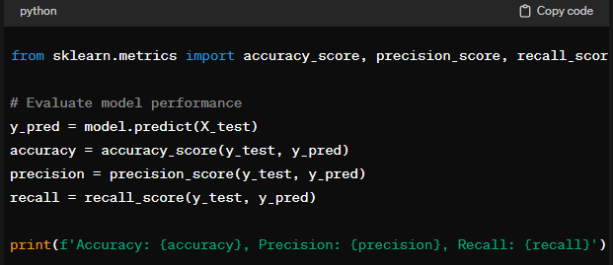

**9. Hyperparameter Tuning:**

• Fine-tune the hyperparameters of the selected models to improve their performance.

• Use techniques like grid search or randomized search to search the hyperparameter space efficiently.

• Hyperparameter optimization:

• Search the hyperparameter space using techniques like grid search, random search, or Bayesian optimization.

• Model selection:

• Select the hyperparameters that yield the best performance on the validation set.

• Grid search: scikit-learn.model_selection.GridSearchCV.

• Random search: scikit-learn.model_selection.RandomizedSearchCV.

• Example: Tuning the regularization parameter in logistic regression or the maximum depth parameter in decision trees.

1. Fine-tune model hyperparameters.
2. Techniques: Grid search, random search.
3. Example: Tune regularization parameter in logistic regression.

Code:

from sklearn.model_selection import GridSearchCV

# Define hyperparameters grid

param_grid = {'C': [0.1, 1, 10, 100]}

# Grid search for hyperparameter tuning

grid_search = GridSearchCV(estimator=LogisticRegression(), param_grid=param_grid, cv=5)

grid_search.fit(X_train, y_train)

best_params = grid_search.best_params_

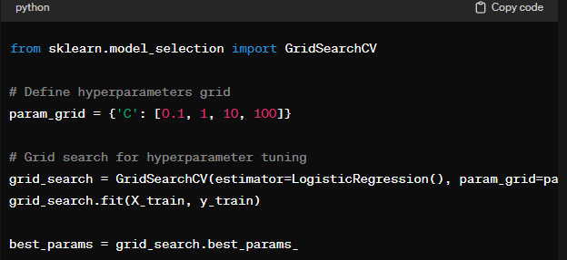

**10. Model Deployment:**

• Deploy the trained machine learning model into production.

• Create APIs or integrate the model into existing systems for real-time predictions.

• Model packaging:

• Serialize trained models into a deployable format (e.g., pickle, joblib).

• Model deployment:

• Deploy the model into production environments (e.g., web servers, cloud platforms).

• Model integration:

• Integrate the model with existing systems or applications to make real-time predictions.

• Serialization: pickle.dump, joblib.dump.

• Deployment: Web frameworks (Flask, Django), cloud platforms (AWS, Azure, Google Cloud).

• Example: Building a web application that predicts customer churn based on user input.

1. Deploy trained model into production.
2. Serialize models, deploy using web frameworks or cloud platforms.
3. Example: Build web application for real-time predictions.

Code:

import joblib

# Serialize trained model

joblib.dump(model, 'churn_prediction_model.pkl')

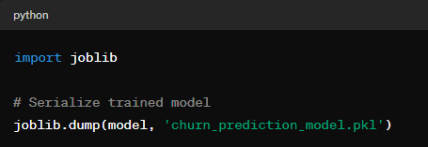

**11. Monitoring and Maintenance:**

• Continuously monitor the performance of the deployed model in production.

• Retrain the model periodically with new data to ensure its accuracy and relevance.

• Performance monitoring:

• Monitor model performance in production environments using appropriate metrics.

• Feedback loop:

• Gather feedback from users and stakeholders to identify model drift and degradation.

• Model retraining:

• Periodically retrain the model with updated data to maintain its accuracy and relevance.

• Model monitoring: Logging, dashboarding tools (e.g., Grafana, Kibana).

• Model retraining: Scheduled pipelines, continuous integration/continuous deployment ( CI/CD) pipelines.

• Example: Monitoring the prediction accuracy of the churn prediction model and retraining it every month with updated customer data.

1. Continuously monitor model performance.
2. Gather feedback, retrain model with updated data.
3. Example: Monitor prediction accuracy, retrain model monthly.

Code:

# Load serialized model

model = joblib.load('churn_prediction_model.pkl')

# Monitor prediction accuracy

accuracy = model.score(X_test, y_test)

print(f'Model Accuracy: {accuracy}')

